**Assignments on Exception Handling.**

1.Write an application that accepts two numbers, divides the first number with the second number and display the result. Hint: You need to handle ArithmeticException which is thrown where there is an attempt to divide a number by zero.

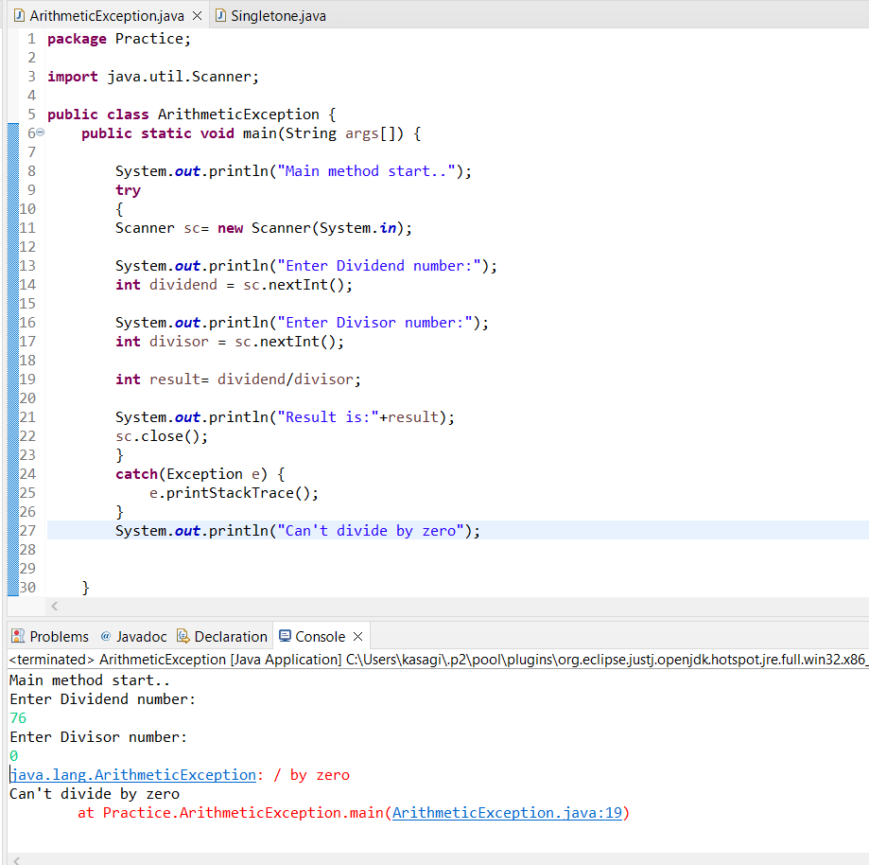

2.Carrying forward with the above problem, handle ArithmeticException by raising UnsupportedOperationException as a solution.

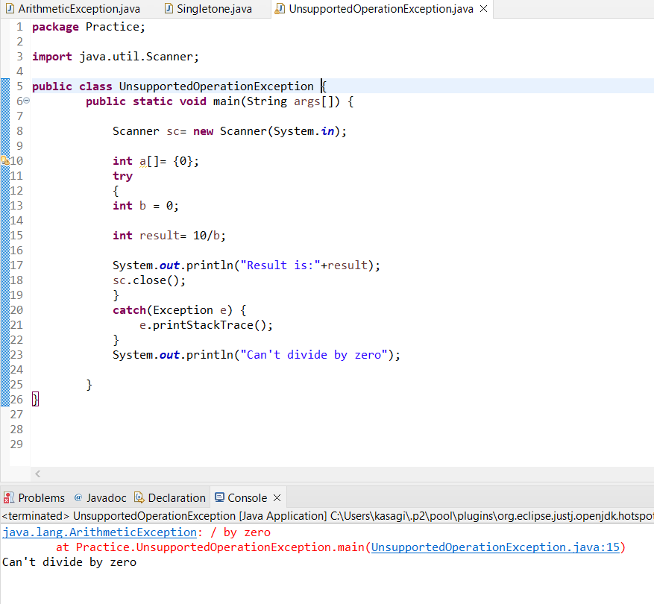

3.Write an application to perform withdraw functionality on a SavingAccount object.

